**The role of environmental filtering on desert ant community assembly**

Jenna Braun and Christopher J. Lortie

Keywords:

**Abstract** (<350 words @ Functional Ecology)

1. To test for ant community assembly

2. We approach the question of desert ant community assembly at two main scales. We used nine sites across the San Joaquin Desert of California, each sampled three times over the summer months. We used population-level trait measurements to study functional dispersion along the gradient with reference to a null model. We then created species distribution models for each species in this study from a curated database of ant occurrences (Guenard et al. 2017), calculate the niche overlap and asked how it relates to traits. It can therefore provide an estimate of the environmental niche overlap between species at the largest scales relevant to the overall distribution of the species across North America.

3. We found that…

4. Discussion

**Introduction**

The extent to which community assembly mechanisms are deterministic processes i.e. niche based is a central topic in ecology. Focussing on traits instead of species identities has emerged as an important tool to understanding the drivers of community assembly processes (Gotzenberger et al. 2012, Swenson 2014, de Bello et al. 2021). Functional traits reflect aspects of morphology, life history or physiology that enable an organism to be successful in an environment (Violle et al. 2007). Trait-based approaches explain assembly processes through the mechanistic link between organisms’ functional traits and their environments and are generalizable because even communities with no species in common can be compared (McGill et al. 2006). Trait-based community assembly theory has primarily been tested in plant ecology (Funk et al. 2017). However, there is a growing recognition of the utility of arthropod trait-based ecology (Brousseau et al. 2018, Wong et al. 2019). Ants are a model animal system to study assembly processes because ant communities are often strongly structured by abiotic environmental conditions (Retana and Cerdá 2000, Gibb et al. 2015) and competition (Camarota et al. 2016), though the latter is the subject of continuing debate (Andersen 2008, Tschinkel and King 2017). Ants are one of the most dominant insect groups in terrestrial ecosystems, and in deserts, many species are keystone taxa through their strong influence on most ecological processes (Whitford 2000). In increasing number of studies have been published linking ant morphological traits and environmental characteristics (Gibb and Parr 2010, Yates et al. 2014, Gibb et al. 2018), as well as traits and ecological function (Kaspari and Weiser 1999, Weiser and Kaspari 2006). The majority of functional ecology papers use traits measured at the species-level (de Bello et al. 2021), however traits captured at the population-level can better reflect environmental filtering (Jung et al. 2010, Violle et al. 2012) and may represent local adaptation (Kawecki and Ebert 2004). Incorporating intraspecific variation into arthropod trait-based ecology is an important step to creating generalizable, mechanistic explanations of the processes that generate and maintain biodiversity.

There are two major hypothesized deterministic processes that predict contrasting but non-exclusive patterns in the trait distributions of coexisting species. Environmental filtering impacts community structure by only allowing only organisms capable of surviving local conditions to persist within the local species pool (Keddy 1992, Vellend 2010). Environmental filtering can therefore lead to a convergence in traits among coexisting species (Weiher and Keddy 1995). In contrast, the concept of limiting similarity suggests that dissimilarity in traits among ecologically similar species can promote coexistence through reducing competition and partitioning resources and the environment (Abrams 1983, Götzenberger et al. 2012). Limiting similarity can therefore lead to a divergence in traits among coexisting species (Weiher and Keddy 1995). Trait convergence can also result from competition if the traits under consideration lead to competitive dominance (Chesson 2000, HilleRisLambers et al. 2012). Therefore, trait similarity is not enough evidence to infer environmental filtering from observational data. It is necessary to also demonstrate that the degree of trait convergence relates to the environmental gradient (Cadotte and Tucker 2017). Examining trait-environment associations and patterns of functional similarity among coexisting species are valuable to understanding processes of community assembly (HilleRisLambers et al. 2012).

The relative importance of environmental and biotic filtering mechanisms can change along environmental stress gradients. The stress-dominance hypothesis of community assembly predicts that environmental filtering should be stronger in more stressful environments and that competition is stronger in relatively benign environments (Weiher and Keddy 1995, Swenson?). These predictions stem from the stress gradient hypothesis of plant community ecology that proposes that competition decreases with increasing environmental stress (Grime 1977, Bertness and Callaway 1994). There is extensive empirical support for the stress gradient hypothesis in plant communities (Lortie and Callaway 2006, He et al. 2013), however, in animal communities, tests are relatively rare. Similarly, most research in community assembly along stress gradients have focussed on plant communities which hinders our ability to generalize to other trophic levels. Most models of coexistence have focused on the impacts of lethal stress instead of species adapted to stressful environments (Kim and Ohr 2020) and neglect the role of facilitation in mediating coexistence (Brooker et al. 2008). In deserts, shrubs reduce environmental stress by reducing daytime heat and retaining warmth overnight, creating locally stable micro-climates which supports local biodiversity (McIntire and Fajardo 2014). Shrub facilitation often increases the cover and biomass of annual plants (Holzapfel et al. 2006, Pugnaire et al. 2011), as well as arthropod species richness and abundance beneath the canopy (Liu et al. 2016, Braun and Lortie 2020, Braun et al. 2021). Therefore, there is the capacity for foundation shrubs to alter taxonomic composition, trait distributions and coexistence patterns of the ant community. Due to the ecological importance and dominance of ants in arid ecosystems (Whitford 2000), understanding how their communities may change under increasing stress and along climatic gradients is important research to predicting the outcome of global change on these ecosystems.

Community assembly mechanisms are widely known to be scale-dependent (Kraft et al. 2015). At the finer spatial scales that species interactions actually occur at, mechanisms related to biotic interactions such as limiting similarity should dominate, giving way to environmental filtering with increasing scale (Weiher et al. 2011). We first studied desert ant community assembly at the regional scale using nine sites across the San Joaquin Desert of California. We used population-level morphological trait measurements to study ant functional dispersion along an environmental stress gradient. Second, we created species distribution models for each ant species collected in this study from occurrence data extracted from a curated database of ant occurrences (Guenard et al. 2017). From the species distribution models we calculated the pairwise dissimilarity in climatic niche overlap, and then compared it to trait dissimilarity to describe patterns at the largest scales relevant to the overall distribution of the species across North America. We examined the hypothesis that desert ant communities are assembled by niche-based processes by testing the following predictions: 1) There will be evidence for environmental filtering on ant communities through the following responses to environmental gradients: a) alpha and beta diversity, b) trait convergence or divergence i.e. changes to functional dispersion, and c) specific trait by environment interactions (community weighted mean trait values will be correlated with environmental gradients); 2) The degree i.e. effect size measure of functional trait dispersion of co-occurring ants will decrease with stress (stress gradient); 3) Dissimilarity in climatic environmental niche between species will be correlated their dissimilarity in traits. These predictions will provide an assessment on the relative importance of environmental filtering and limiting similarity along stress gradients at regional scales. The larger scale analysis will answer if traits are related to the overall distribution overlap between species. Combining taxonomic with trait-based approaches can provide insight into the mechanisms driving environmental and biotic filtering, as well as the spatial scale at which these processes operate for ant communities (Fichaux et al. 2019).

**Methods**

*Field collection*

Ant communities (Hymenoptera: Formicidae) were sampled using pitfall traps at nine sites in the San Joaquin Valley, California, USA that span a distance of ~200 km from north to south (Figure 1). Each site was sampled once per month between July and September of 2020 for a total of 27 sampling instances (Appendix Table 1). The shrub species *Ephedra californica* (Ephedraceae) and *Atriplex* sp. (Chenopodiaceae) are the dominant perennial species at six of the sites and the remaining three sites are relatively open with few shrubs. White plastic drink cups (12.4 cm tall, 9 cm diameter) were placed with the top of the cup flush with the ground. In order to prevent vertebrate bycatch, 0.5-inch hardware cloth was placed horizontally within the trap and a piece of aluminum flashing was elevated three cm above the trap to shelter the trap. The traps were filled to a depth of three cm with 100% propylene glycol. Propylene glycol is a biodegradable, non-toxic preservative that does not evaporate and preserves DNA (Nakamura et al. 2020). At shrub sites, traps were placed at 12 pairs of shrub/open microsites and pairs were located at least 10 m apart. Shrub microsites were located beneath the canopy of a foundation shrub at the center of a 0.5 m quadrat placed just inside the dripline of the shrub. Open microsites were located randomly at least 2 m away from shrub microsites. At sites without shrubs in collections areas (i.e. within 500 -1000 m of collections), pitfalls traps were deployed every 10 m in open areas along two transects located at least 10 m apart. At each site, 24 pitfall traps were deployed continuously for 72 hours per sampling event. Each sampling location was georeferenced using a handheld GPS unit. The traps were deployed in different locations within the study site each month to avoid repeated measures. Throughout the season, 648 traps were deployed totaling 46 656 trap-hours (24 traps per site * 3 sampling instances * 72 hours). Site-level vegetation characteristics were measured each month by placing 0.5 m quadrats every 4 m in ten 25 m transects distributed around the site and recording the percent cover of ground-covering vegetation, rocky cover, woody cover and bare ground within the quadrat. Vegetation height was measured at the center of the quadrat.

*Lab work*

Ants were first identified to genus using Fisher & Cover (2007), and to species using AntWiki keys (www.antwiki.org). Representative individuals of each species were also barcoded by the Canadian Centre for DNA Barcoding (CCD). The resulting COI? sequences were compared to BINs in BOLD systems (https://boldsystems.org/). Two singletons, *Solenopsis molesta* and *Solenopsis aurea* were excluded from analyses. We measured the following morphological trait data from the ant specimens: Weber’s length, which is the length of the longest diagonal on the thorax and a measure of overall worker body size (Brown 1953); femur length, which relates to foraging ability in complex environment and thermoregulation (Feener Jr et al. 1988); mandible length, and head length and width, which relate to diet; scape length, which relates to chemosensory abilities; and eye size which relates to foraging behaviours (Weiser and Kaspari 2006). The latter six traits were divided by Weber’s body length to remove the impact of body size.

We measured each of the seven traits in up to six individuals per species, per site (265 individual ants) to capture the intraspecific variation in traits between populations. We dissected each ant and affixed them to microscope slides using Elmer’s glue. We placed each ant mount slide on top of a stage micrometer slide and took focus-bracketed photographs using a Canon 60D DSLR camera with a 60 mm macro lens and Canon EF 25 II extension tube. Helicon Focus software was used to combine the focus stacks into single images. We imported each composite image into ImageJ software and used the micrometer divisions within the image to calibrate the measurement scale within the software and then measured each trait using the software.

*Analysis*

We extracted the mean annual precipitation, mean annual temperature and maximum annual temperature for each site from WorldClim (Fick and Hijmans 2017). We extracted NDVI (normalized difference vegetation index) from EVIIRS (USGS EROS Visible Infrared Imaging Radiometer Suite). EVIIRS has a 375 m spatial resolution, and 7 and 14 day temporal resolution (USGS, 2021). We used the NDVI measurement collected from the date closest to the field sampling date (Appendix Table 2). NDVI is often used as an estimate of plant productivity within animal ecology (Pettorelli et al. 2011). We additionally extracted two below-ground measures from a recently published dataset of global soil temperature: mean annual soil temperature and the annual range of soil temperatures, both at the 5cm to 15 cm depth (Lembrechts et al. 2022).

All analyses used R version 4.1.0 (R Core Team 2022). Ants forage socially and this leads to clustering of individuals from the same colony (Longino and Coddington 2002). We converted the ant data from abundance to occupancy i.e. the proportion of pitfall traps at site that each ant species was detected in. We calculated site-level vegetation cover and height by taking the mean value of the 40 quadrats. We calculated variation in vegetation cover by taking the standard deviation of cover within the quadrats.

We combined the environmental variables (mean annual precipitation, mean annual temperature and maximum annual temperature, NDVI, mean annual soil temperature, annual range of soil temperatures, mean percent vegetation cover, variation in vegetation cover and mean annual vegetation height) into a composite environmental gradient using PCA. Prior to the PCA all variables were standardized to a mean of zero and unit variance (decostand: vegan, Oksanen et al. 2010).

We calculated functional dispersion (FDisp) for each of the 27 sites using the population-level trait means using the dbFD functioning in the FD package (Laliberté et al. 2014). Fdisp is the weighted average distance of species to the centroid in multivariate trait space and a measure of multivariate dispersion (Laliberté et al. 2014).

In order to test if the observed communities were functionally clustered or dispersed, we compared the observed communities to a null model. We generated 1000 random communities using the RandomizeMatrix function in the picante package (Kembel et al. 2010). The null models were generated using the independent swap algorithm, which holds rows sums i.e. species richness and column sums i.e. occupancy/abundance of each population constant while randomizing. FDisp was calculated for each of these 1000 matrices. Standardized effect size (SES) was then calculated for each site using the following formula: (Obs – MeanRandom)/SD Random) (Swenson 2014). Positive values of SES indicate that a community is functionally dispersed, whereas negative values indicate functional trait clustering (de Bello et al. 2021). A one sample t-test was used to determine if the mean value of SES across all the populations was significantly different than zero i.e. clustered or dispersed (de Bello et al. 2021). To determine if environmental filtering impacts SES scores along the environmental gradient, we regressed the SES scores against the first axis of the PCA (PC1).

We used variance partitioning to quantify the relative contribution of environmental factors, pure space i.e. dispersal limitations and history, and spatially structured environmental factors on variation in SES functional dispersion. By controlling for spatial auto-correlation, variance partitioning is able to quantify the component of variation resulting solely from environmental factors (Smith and Lundholm 2010). We converted the WGS 1984 site coordinates to cartesian coordinates using the geoXY function in the SoDA package (Chambers 2020). We then created Moran’s eigenvector maps (MEMs) from the cartesian coordinates using the dbmem function in adespatial (Dray et al. 2018). We used the SES functional dispersion values as the response, and the standardized environmental variable matrix i.e. the same matrix as the PCA input and the MEM matrix as predictors (varpart: vegan, Oksanen et al. 2010).

We calculated the community-weighted mean (CWM) trait values for each trait using the dbFD function in the FD package (Laliberté et al. 2014). In order to test if the mean value of each trait is correlated with environmental gradient, we regressed the CWM for each trait against the PC1 axis.

To describe general taxonomic diversity patterns, we fit a poisson GLM with species richness as the response and the PC1 and PC2 axes. We also decomposed taxonomic beta diversity into occupancy weighted turnover and nestedness components (betapart package, Baselga and Orme 2012, Baselga 2013). To test if the components of beta-diversity are related to the environment, we calculated the Euclidean distance between sites using the standardized environmental matrix and used Mantel tests to test for correlations.

*Large scale environmental niche overlap*

We conducted an additional set of analyses to examine the relationship between overall climatic niche overlap and trait similarity. We extracted occurrence data from the Global Ant Biodiversity Informatics (GABI) database (Guenard et al. 2017) for each of the 11 ant species in our study. We excluded the Brazilian occurrence points for *Dorymyrmex insanus* because they were the only points south of Panama and they are likely *D. pyramicus* (Cuezzo and Guerrero 2012). For each species, occurrence points were thinned to one point per raster cell to reduce spatial bias. We generated pseudo-absences by randomly sampling 10000 points using the randompoints function from the dismo package (Hijmans et al. 2017). For each species, the background sampling area was determined by buffering the minimum convex hull of the occurrences by 100 km. This step was done to ensure that the background points were relevant to the range of each species. Mean annual temperature, maximum annual temperature and mean annual precipitation rasters from Worldclim, and mean and range of annual soil temperature rasters were used as input into species distribution models. The two soil rasters were resampled using bilinear interpolation to match the cells and extent of the climate rasters. The rasters were clipped to the following extent: -140, 7; -70, 50. Thus, the area used to generate pseudoabsences was unique for each species and the area used for prediction i.e. the extent of the rasters was identical for all species to allow for the comparison of model predictions. We used the package ENMeval (Muscarella et al. 2017) to create species distribution models for each of the ant species. This package implements the MaxEnt algorithm. The approach used by ENMeval runs a series of models in succession, using different combinations of tuning parameters to avoid overfitting while maximizing goodness of fit. We used regularization values between 1 and 5, as well as the following feature classes: linear, linear + quadratic, hinge, linear + quadratic + hinge, which correspond to settings described within the packages vignette (Muscarella et al. 2017). We used random k folds at a value of five to determine which partitions to hold back for model validation. We chose models from the range of candidate models by using the one with the lowest AIC value. We assessed the predictive performance of each model using the area under the receiver operating characteristic curve (AUC). For the resulting SDM prediction rasters, we calculated Schoener’s D i.e. climatic niche overlap for each pair of species using the function calc.niche.overlap (Muscarella et al. 2017). We converted Shoener’s D to a dissimilarity index by subtracting each value from one. We then computed Gower dissimilarity for each pair of species using the species level mean trait values. We used a Mantel test to test if the dissimilarity in traits is correlated with the dissimilarity in climatic niche overlap between species (Oksanen et al. 2010). Significance was assessed using 999 permutations.

**Results**

A total of 15519 individual ants from 11 species were collected and identified. All species are native to California. The most abundant species were *Solenopsis xyloni*, the native Southern fire ant, and *Pheidole hyatti*, the big-headed ant. Mean species richness per site was 4.1 +/- 1.42SD and ranged from a minimum of two species to a maximum of eight species.

The first PCA axis explained 50.01% of the environmental variation (Figure 2). Mean annual precipitation, maximum and mean annual temperature, and mean vegetation height were the largest environmental contributors to the PC1 axis. The composite environmental gradient was therefore cooler, wetter sites (negative PC1 values) to hotter, drier sites (positive PC1 values).

*Taxonomic diversity patterns*

Alpha diversity was not significantly predicted by PC1 (GLM: p = 0.187) or PC2 (GLM: p = 0.25). Taxonomic beta diversity was dominated by the turnover component (87.9%). Nestedness accounted for the remaining 12.1% of observed taxonomic beta diversity. The nestedness component of beta diversity was significantly correlated with environmental distance (Mantel r: 0.164, p = 0.028), however, the turnover component was not significantly correlated with the environment (Mantel r: 0.082, p = 0.135).

*Assembly patterns*

There was evidence for significant trait divergence as mean SES functional dispersion (0.58 ± 0.86 SD) was significantly greater than zero (t-test, t = 3.54, p = 0.002). Functional trait divergence SESfdisp significantly decreased as PC1 increased (R2adj = 0.165, coef = -0.507, p = 0.019) but not PC2 (coef = 0.17, p = 0.4) (Figure 2). SESfdisp was not significantly different between sites with large foundation shrubs and sites comprised of open areas (lm, coef: -0.06, p = 0.86).

*Variance partitioning*

Environmental predictors explained 19% of the variation in SESfdisp, spatially distributed environmental factors explained 32% of the variation and pure space contributed 0% (Appendix Figure 3). Variation that remained unexplained by environment and space i.e. residual was 51%.

*Community-weighted mean traits*

Weber’s body length (R2adj = 0.26, p = 0.004) and relative femur length (R2adj = 0.243, p = 0.005) were both significantly and negatively correlated with the PC1 gradient (Figure 4). The remaining traits were not significantly related to the PC1 gradient. The contribution of intraspecific variation to overall trait variation depended on the trait (Figure 5).

*Large scale analyses*

Dissimilarity in climatic niche overlap (complement of Shoener’s D) was significantly correlated with Gower dissimilarity in traits (Mantel r: 0.03776, p = 0.028). All SDMs had an AUC > 0.7 and odds < .15 (Appendix Table xx).

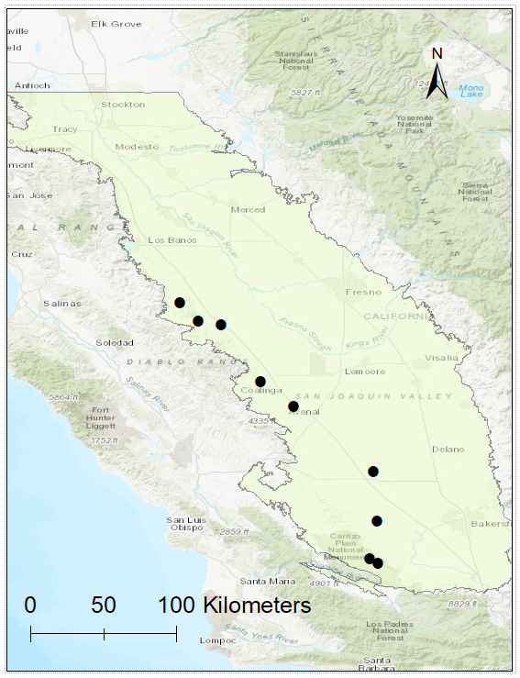

Figure 1: A map of the nine study areas. The San Joaquin Valley is the light green area.

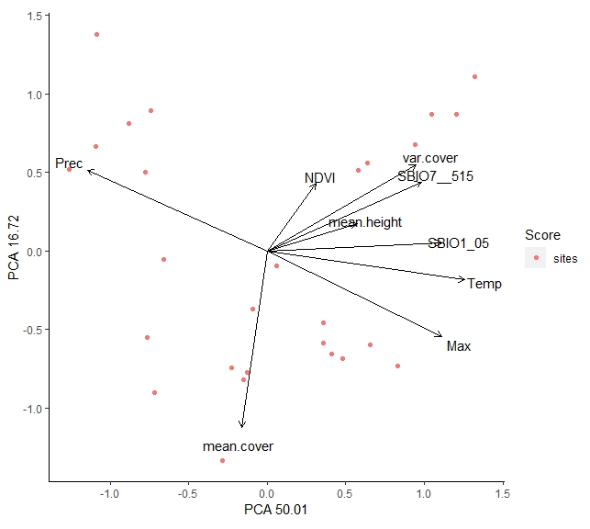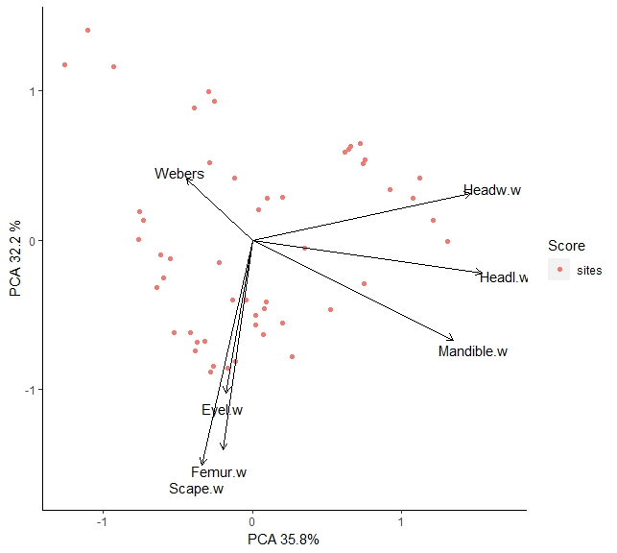

Figure 2: The relationship among environmental variables (A), and among traits (B). Principal components analysis was used to combine environmental variables into a compositive environmental gradient. The gradient ranges from relatively hot and dry to cooler and wetter.

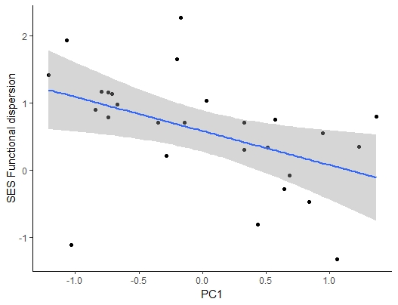

Figure 3: The relationship between the standardized effect size of functional dispersion and the composite environmental gradient (PC1). The shaded gray band represents the 95% confidence interval. The black points represent sampling instances.

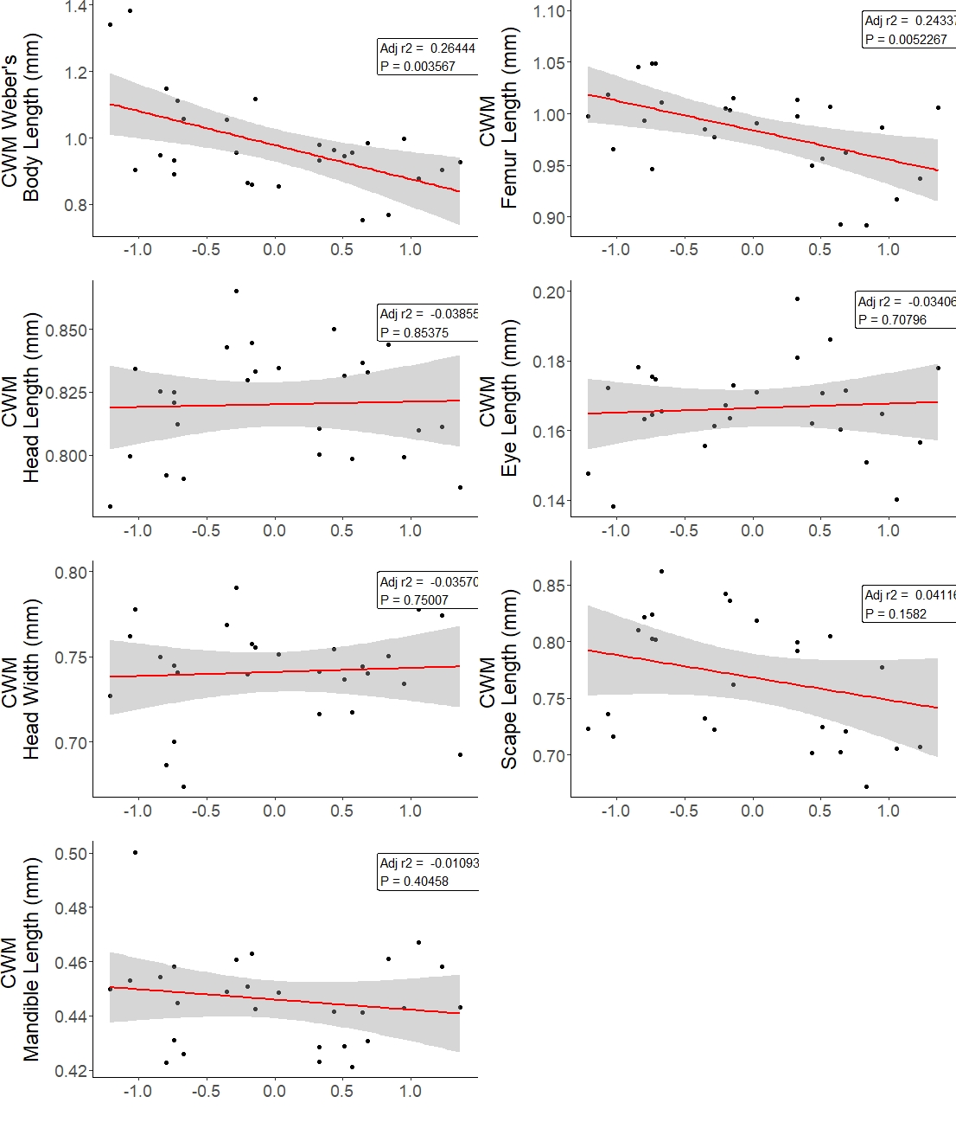

Figure 4: Linear regressions of community-weighted mean trait values and the composite environmental gradient (PC1). Sites with higher annual temperatures and lower annual precipitation are higher on the PC1 gradient. The shaded gray band represents the 95% confidence interval.

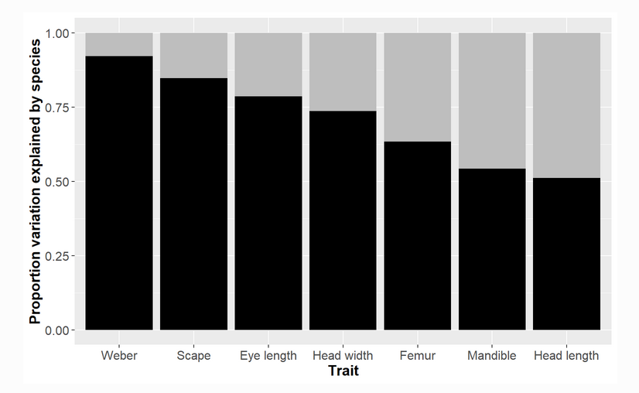

Figure 5: ITV and traits

**Discussion**

Our results show that ant community assembly in Californian deserts is strongly influenced by the environmental stress, leading to signatures in both the functional trait and taxonomic community structure. Overall, our evidence supports the hypothesis that desert ant communities are assembled through niche-based processes. At the local site level, the ant community was significantly functionally dispersed in terms of morphological traits. Functional trait dispersion is the signature of limiting similarity which suggests the greater importance of interspecific interactions, specifically competition and niche partitioning in structuring the community (Weiher and Keddy 1995, Gotzenberger et al. 2012). However, we also found that the degree of functional dispersion was significantly correlated with the environmental stress gradient. 49% of the variation in dispersion was related to the environment, or space and environment. We found that 0% was attributable to pure space. Pure space is dispersal limitation. This suggests that this was not an issue. The final 51% can be attributable to other drivers, including biotic interactions. The presence of large foundational shrubs did not impact the degree of functional dispersion, nor did PC2 which was more strongly related to vegetation. We found additional evidence for environment filtering by examining community weight mean trait values for individual traits. Body size and relative femur length were significantly and positively correlated with the gradient. Therefore, environmental filtering and limiting similarity are jointly and non-independently structuring the ant community. Most frameworks of community assembly warn of the non-independence (Hillres etc). Instead, the importance of biotic filters is mediated through or dependent on the environmental conditions that the interactions take place. Our results highlight that the filters are synthetic but that the frameworks allow them to both be detected.

As sites became relatively hotter and drier, the ant communities shifted from functionally dispersed to randomly assembled. We interpret this finding as consistent with the predictions of the stress dominance hypothesis, which predicts a breakdown in the importance of competition with increasing environmental stress (Swenson and Enquist). Animal ecology is beginning to benefit from the stress-trait frameworks that have been developed for plant ecology. Ants are primarily sessile, reproductive do the dispersing. While whole colonies can disperse long distances, and in some ecosystems eg army ants are very mobile. Our results suggest that stress gradients have the same predicted impact on ant functional dispersion, as stress increased functional diversity decreased. Competition is a paradigm of ant community ecology. We found evidence for overdispersion at smaller scales which is consistent with the predictions of modern coexistence theory (Chesson 2000). Overdispersion was strongest at the most benign study sites and trended towards 0 with increasing environmental stress.

Assembly processes are scale-dependent. Data collected at local scales is important to inferring assembly mechanisms because it represents the scales that species can interact with each other (Graham et al. 2014). However, a local community is assembled from a larger community, so a local community is still subject to the constraints of the larger community. We found evidence for environmental filtering at larger scales. Using regional mean species trait values and niche modelling, we found evidence consistent with the predictions of environmental filtering - species more similar in environmental niches are also more similar in morphological traits. [I need to go back to the models and determine what the most important drivers were]. There was also evidence for larger scale environmental filtering from beta-diversity. We also found that the nestedness component of taxonomic beta diversity was correlated with the environment. Nestedness is the non-random loss of species The nestedness component is changes in abundances of species – species losses or gains with the environment. In contrast to our expectations, species richness was not significantly correlated with the environmental gradient. The nestedness component of taxonomic beta-diversity was significantly correlated with the environmental gradient, but not the turnover component.

We found evidence for community-wide relationships between ant Weber’s body length and relative femur length, and the composite environmental gradient. Body size relates to many physiological traits. Increased body size is also related to Bergamm’s rule/startvation resistance hypothesis). Femur length is thought to be related to habitat complexity, with shorter legs making them more manoeuvrable in complex environments. Increased leg length makes them faster. In Europe, ant body size increases with latitude (Cushman et al. 1993). It has been found that femur length has a negative association with temperature at the individual worker level in a gradient across Quebec (Ibarra-Isassi et al. 2022). We found it decreased along our gradient as well. We found body size decreases too. (Wiescher et al. 2012) found that ants in hotter, drier habitats had longer legs but this is central Florida where it is not that dry. Surface complexity can act as a filter on ant traits, for example longer-legged ant species are more successful on rugose surfaces that short-legged species (Kaspari and Weiser 1999). Therefore

**Appendix**

Table 1: Summary of sampling dates and locations.

|  |  |  |  |  |
| --- | --- | --- | --- | --- |
| Site Name | Pitfall Trap Sampling dates | Coordinate of site centroid | | |
|  | |  | | |
| CaS | July 10 - 13 | | 35.11995 | 119.6283 | |
| Aug 2 - 5 | | 35.12000 | 119.6280 | |
| Sept 18 - 21 | | 35.11600 | 119.6240 | |
| CaSl | July 9 - 12 | | 35.09 | -119.574 | |
| Aug 2 - 5 | | 35.089 | -119.576 | |
| Sept 18 - 21 | | 35.065 | -119.539 | |
| SemiT | July 15 - 18 | | 35.658 | -119.612 | |
| Aug 6 - 9 | | 35.658 | -119.612 | |
| Sept 24 – 27 | | 35.658 | -119.61 | |
| Lokern | July 14 - 17 | | 35.354 | -119.584 | |
| Aug 3 - 6 | | 35.354 | -119.584 | |
| Sept 23 - 26 | | 35.355 | -119.588 | |
| PaPl | July 23 - 27 | | 36.698 | -120.799 | |
| Aug 12 - 15 | | 36.696 | -120.795 | |
| Sept 10 -13 | | 36.7 | -120.801 | |
| Aven | July 21 - 24 | | 36.094 | -120.197 | |
| Aug 8 - 11 | | 36.088 | -120.19 | |
| Sept 6 - 9 | | 36.0878 | -120.1912 | |
| Mov | July 28 - 31 | | 36.563 | -120.547 | |
| Aug 13 - 16 | | 36.562 | -120.545 | |
| Sept 12 - 16 | | 36.561 | -120.548 | |
| SiCr | July 20 - 23 | | 36.586 | -120.687 | |
| Aug 12- 15 | | 36.586 | -120.686 | |
| Sept 12 - 16 | | 36.586 | -120.688 | |
| Coal | July 16 - 19 | | 36.213 | -120.305 | |
| Aug 8 - 11 | | 36.212 | -120.304 | |
| Sept 6 – 9 | | 36.213 | -120.303 | |

Table 2: Scene ID

|  |  |  |  |  |
| --- | --- | --- | --- | --- |
| eVIIRS NDVI | EVUSS20200630202007066 | EVIIRS NDVI 375M | 154.78 MiB | Complete |
| eVIIRS NDVI | EVUSS20200707202007136 | EVIIRS NDVI 375M | 155.12 MiB | Complete |
| eVIIRS NDVI | EVUSS20200714202007206 | EVIIRS NDVI 375M | 154.11 MiB | Available |
| eVIIRS NDVI | EVUSS20200714202007276 | EVIIRS NDVI 375M | 169.38 MiB | Complete |
| eVIIRS NDVI | EVUSS20200721202007276 | EVIIRS NDVI 375M | 154.01 MiB | Complete |
| eVIIRS NDVI | EVUSS20200728202008036 | EVIIRS NDVI 375M | 154.96 MiB | Available |
| eVIIRS NDVI | EVUSS20200728202008106 | EVIIRS NDVI 375M | 170.24 MiB | Complete |
| eVIIRS NDVI | EVUSS20200804202008106 | EVIIRS NDVI 375M | 155.96 MiB | Available |
| eVIIRS NDVI | EVUSS20200811202008176 | EVIIRS NDVI 375M | 155.71 MiB | Available |
| eVIIRS NDVI | EVUSS20200811202008246 | EVIIRS NDVI 375M | 168.62 MiB | Available |
| eVIIRS NDVI | EVUSS20200818202008246 | EVIIRS NDVI 375M | 153.81 MiB | Available |
| eVIIRS NDVI | EVUSS20200825202008316 | EVIIRS NDVI 375M | 153.74 MiB | Available |
| eVIIRS NDVI | EVUSS20200825202009076 | EVIIRS NDVI 375M | 167.25 MiB | Available |
| eVIIRS NDVI | EVUSS20200901202009076 | EVIIRS NDVI 375M | 152.77 MiB | Available |
| eVIIRS NDVI | EVUSS20200908202009146 | EVIIRS NDVI 375M | 147.03 MiB | Available |
| eVIIRS NDVI | EVUSS20200908202009216 | EVIIRS NDVI 375M | 162.40 MiB | Available |
| eVIIRS NDVI | EVUSS20200915202009216 | EVIIRS NDVI 375M | 150.21 MiB | Available |
| eVIIRS NDVI | EVUSS20200922202010056 | EVIIRS NDVI 375M | 162.86 MiB | Available |

*From <*[*https://dds.cr.usgs.gov/queue/orderlist/BulkDownload/20220822_104216/1*](https://dds.cr.usgs.gov/queue/orderlist/BulkDownload/20220822_104216/1)*>*

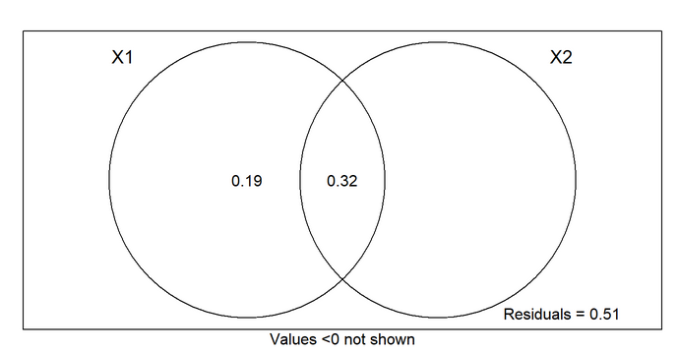

Figure 3: Variance partitioning

Supplemental Information

Table S1: Population level trait measurements

Literature Cited

USGS EROS Archive - Vegetation Monitoring - EROS Visible Infrared Imaging Radiometer Suite (eVIIRS) , https://doi.org/10.5066/P9Q3B2A7

Abrams, P. 1983. The theory of limiting similarity. Annual review of ecology and systematics 14:359–376.

Andersen, A. N. 2008. Not enough niches: non‐equilibrial processes promoting species coexistence in diverse ant communities. Austral ecology 33:211–220.

Baselga, A. 2013. Separating the two components of abundance-based dissimilarity: balanced changes in abundance vs. abundance gradients. METHODS IN ECOLOGY AND EVOLUTION 4:552–557.

Baselga, A., and C. Orme. 2012. betapart: an R package for the study of beta diversity. METHODS IN ECOLOGY AND EVOLUTION 3:808–812.

de Bello, F., C. P. Carmona, A. T. Dias, L. Götzenberger, M. Moretti, and M. P. Berg. 2021. Handbook of trait-based ecology: from theory to R tools. Cambridge University Press.

Bertness, M. D., and R. Callaway. 1994. Positive interactions in communities. Trends in Ecology & Evolution 9:191–193.

Braun, J., and C. Lortie. 2020. Facilitation with a grain of salt: Reduced pollinator visitation is an indirect cost of association with the foundation species Creosote bush (Larrea tridentata). American journal of botany 107.

Braun, J., M. Westphal, and C. J. Lortie. 2021. The shrub Ephedra californica facilitates arthropod communities along a regional desert climatic gradient. Ecosphere 12:e03760.

Brooker, R. W., F. T. Maestre, R. M. Callaway, C. L. Lortie, L. A. Cavieres, G. Kunstler, P. Liancourt, K. Tielbörger, J. M. Travis, and F. Anthelme. 2008. Facilitation in plant communities: the past, the present, and the future. Journal of Ecology 96:18–34.

Brousseau, P.-M., D. Gravel, and I. T. Handa. 2018. On the development of a predictive functional trait approach for studying terrestrial arthropods. Journal of Animal Ecology 87:1209–1220.

Brown, W. L. 1953. Revisionary studies in the ant tribe Dacetini. The American Midland Naturalist 50:1–137.

Cadotte, M. W., and C. M. Tucker. 2017. Should Environmental Filtering be Abandoned? Trends in Ecology & Evolution 32:429–437.

Camarota, F., S. Powell, A. S. Melo, G. Priest, R. J. Marquis, and H. L. Vasconcelos. 2016. Co‐occurrence patterns in a diverse arboreal ant community are explained more by competition than habitat requirements. Ecology and evolution 6:8907–8918.

Chambers, J. 2020. Package ‘SoDA.

Chesson, P. 2000. Mechanisms of Maintenance of Species Diversity. Annual Review of Ecology and Systematics 31:343–366.

Cuezzo, F., and R. J. Guerrero. 2012. The Ant Genus *Dorymyrmex* Mayr (Hymenoptera: Formicidae: Dolichoderinae) in Colombia. Psyche: A Journal of Entomology 2012:1–24.

Cushman, J. H., J. H. Lawton, and B. F. J. Manly. 1993. Latitudinal patterns in European ant assemblages: variation in species richness and body size. Oecologia 95:30–37.

Dray, S., G. Blanchet, D. Borcard, G. Guenard, T. Jombart, G. Larocque, P. Legendre, N. Madi, H. H. Wagner, and M. S. Dray. 2018. Package ‘adespatial.’ R Package 2018:3–8.

Feener Jr, D. H., J. R. B. Lighton, and G. A. Bartholomew. 1988. Curvilinear allometry, energetics and foraging ecology: a comparison of leaf-cutting ants and army ants. Functional Ecology:509–520.

Fichaux, M., B. Béchade, J. Donald, A. Weyna, J. H. C. Delabie, J. Murienne, C. Baraloto, and J. Orivel. 2019. Habitats shape taxonomic and functional composition of Neotropical ant assemblages. Oecologia 189:501–513.

Fick, S. E., and R. J. Hijmans. 2017. WorldClim 2: new 1‐km spatial resolution climate surfaces for global land areas. International journal of climatology 37:4302–4315.

Fisher, B. L., and S. P. Cover. 2007. Ants of North America: a guide to the genera. Univ of California Press.

Funk, J. L., J. E. Larson, G. M. Ames, B. J. Butterfield, J. Cavender‐Bares, J. Firn, D. C. Laughlin, A. E. Sutton‐Grier, L. Williams, and J. Wright. 2017. Revisiting the H oly G rail: using plant functional traits to understand ecological processes. Biological Reviews 92:1156–1173.

Gibb, H., and C. L. Parr. 2010. How does habitat complexity affect ant foraging success? A test using functional measures on three continents. Oecologia 164:1061–1073.

Gibb, H., N. J. Sanders, R. R. Dunn, X. Arnan, H. L. Vasconcelos, D. A. Donoso, A. N. Andersen, R. R. Silva, T. R. Bishop, C. Gomez, B. F. Grossman, K. M. Yusah, S. H. Luke, R. Pacheco, J. Pearce-Duvet, J. Retana, M. Tista, and C. L. Parr. 2018. Habitat disturbance selects against both small and large species across varying climates. Ecography 41:1184–1193.

Gibb, H., N. J. Sanders, R. R. Dunn, S. Watson, M. Photakis, S. Abril, A. N. Andersen, E. Angulo, I. Armbrecht, and X. Arnan. 2015. Climate mediates the effects of disturbance on ant assemblage structure. Proceedings of the Royal Society B: Biological Sciences 282:20150418.

Gotzenberger, L., F. de Bello, K. A. Brathen, J. Davison, A. Dubuis, A. Guisan, J. Leps, R. Lindborg, M. Moora, M. Partel, L. Pellissier, J. Pottier, P. Vittoz, K. Zobel, and M. Zobel. 2012. Ecological assembly rules in plant communities--approaches, patterns and prospects. Biol Rev Camb Philos Soc 87:111–27.

Götzenberger, L., F. de Bello, K. A. Bråthen, J. Davison, A. Dubuis, A. Guisan, J. Lepš, R. Lindborg, M. Moora, M. Pärtel, L. Pellissier, J. Pottier, P. Vittoz, K. Zobel, and M. Zobel. 2012. Ecological assembly rules in plant communities-approaches, patterns and prospects. Biological Reviews 87:111–127.

Graham, C. H., A. C. Carnaval, C. D. Cadena, K. R. Zamudio, T. E. Roberts, J. L. Parra, C. M. McCain, R. C. K. Bowie, C. Moritz, S. B. Baines, C. J. Schneider, J. VanDerWal, C. Rahbek, K. H. Kozak, and N. J. Sanders. 2014. The origin and maintenance of montane diversity: integrating evolutionary and ecological processes. Ecography 37:711–719.

Grime, J. P. 1977. Evidence for the existence of three primary strategies in plants and its relevance to ecological and evolutionary theory. The American Naturalist 111:1169–1194.

Guenard, B., M. D. Weiser, K. Gomez, N. Narula, and E. P. Economo. 2017. The Global Ant Biodiversity Informatics (GABI) database: synthesizing data on the geographic distribution of ant species (Hymenoptera: Formicidae). Myrmecological News/Osterreichische Gesellschaft fur Entomofaunistik 24:83–89.

He, Q., M. D. Bertness, and A. H. Altieri. 2013. Global shifts towards positive species interactions with increasing environmental stress. Ecology letters 16:695–706.

Hijmans, R. J., S. Phillips, J. Leathwick, J. Elith, and M. R. J. Hijmans. 2017. Package ‘dismo.’ Circles 9:1–68.

HilleRisLambers, J., P. B. Adler, W. S. Harpole, J. M. Levine, and M. M. Mayfield. 2012. Rethinking Community Assembly through the Lens of Coexistence Theory. Annual Review of Ecology, Evolution, and Systematics 43:227–248.

Holzapfel, C., K. Tielbörger, H. A. Parag, J. Kigel, and M. Sternberg. 2006. Annual plant–shrub interactions along an aridity gradient. Basic and Applied Ecology 7:268–279.

Ibarra-Isassi, J., I. T. Handa, and J.-P. Lessard. 2022. Community-wide trait adaptation, but not plasticity, explains ant community structure in extreme environments. Functional Ecology n/a.

Jung, V., C. Violle, C. Mondy, L. Hoffmann, and S. Muller. 2010. Intraspecific variability and trait-based community assembly: Intraspecific variability and community assembly. Journal of Ecology 98:1134–1140.

Kaspari, M., and M. D. Weiser. 1999. The size–grain hypothesis and interspecific scaling in ants. Functional Ecology 13:530–538.

Kawecki, T. J., and D. Ebert. 2004. Conceptual issues in local adaptation. Ecology Letters 7:1225–1241.

Keddy, P. A. 1992. Assembly and response rules: two goals for predictive community ecology. Journal of Vegetation Science 3:157–164.

Kembel, S. W., P. D. Cowan, M. R. Helmus, W. K. Cornwell, H. Morlon, D. D. Ackerly, S. P. Blomberg, and C. O. Webb. 2010. Picante: R tools for integrating phylogenies and ecology. Bioinformatics 26:1463–1464.

Kim, D., and S. Ohr. 2020. Coexistence of plant species under harsh environmental conditions: an evaluation of niche differentiation and stochasticity along salt marsh creeks. Journal of Ecology and Environment 44:1–16.

Kraft, N. J. B., P. B. Adler, O. Godoy, E. C. James, S. Fuller, and J. M. Levine. 2015. Community assembly, coexistence and the environmental filtering metaphor. Functional Ecology 29:592–599.

Laliberté, E., P. Legendre, B. Shipley, and M. E. Laliberté. 2014. Package ‘FD.’ Measuring functional diversity from multiple traits, and other tools for functional ecology:1.0-12.

Lembrechts, J. J., M. B. Ashcroft, P. D. Frenne, J. Kemppinen, M. Kopecký, M. Luoto, I. M. D. Maclean, T. W. Crowther, J. J. Bailey, S. Haesen, D. H. Klinges, P. Niittynen, B. R. Scheffers, K. V. Meerbeek, P. Aartsma, O. Abdalaze, M. Abedi, R. Aerts, N. Ahmadian, A. Ahrends, J. M. Alatalo, J. M. Alexander, C. N. Allonsius, J. Altman, C. Ammann, C. Andres, C. Andrews, J. Ardö, N. Arriga, A. Arzac, V. Aschero, R. L. Assis, J. J. Assmann, M. Y. Bader, K. Bahalkeh, P. Barančok, I. C. Barrio, A. Barros, M. Barthel, E. W. Basham, M. Bauters, M. Bazzichetto, L. B. Marchesini, M. C. Bell, J. C. Benavides, J. L. B. Alonso, B. J. Berauer, J. W. Bjerke, R. G. Björk, M. P. Björkman, K. Björnsdóttir, B. Blonder, P. Boeckx, J. Boike, S. Bokhorst, B. N. S. Brum, J. Brůna, N. Buchmann, P. Buysse, J. L. Camargo, O. C. Campoe, O. Candan, R. Canessa, N. Cannone, M. Carbognani, J. Carnicer, A. Casanova, S. Cesarz, B. Chojnicki, P. Choler, S. L. Chown, E. F. Cifuentes, M. Čiliak, T. Contador, P. Convey, E. J. Cooper, E. Cremonese, S. R. Curasi, R. Curtis, M. Cutini, C. J. Dahlberg, G. N. Daskalova, M. A. de Pablo, S. D. Chiesa, J. Dengler, B. Deronde, P. Descombes, V. D. Cecco, M. D. Musciano, J. Dick, R. D. Dimarco, J. Dolezal, and E. Dorrepaal. 2022. Global maps of soil temperature:35.

Liu, H., H. Jacquemyn, W. Chen, S. B. Janssens, X. He, S. Yu, and Y. Huang. 2021. Niche evolution and historical biogeography of lady slipper orchids in North America and Eurasia. Journal of Biogeography 48:2727–2741.

Liu, R., F. Zhu, and Y. Steinberger. 2016. Changes in ground-dwelling arthropod diversity related to the proximity of shrub cover in a desertified system. Journal of arid environments 124:172–179.

Longino, J. T., and J. Coddington. 2002. THE ANT FAUNA OF A TROPICAL RAIN FOREST: ESTIMATING SPECIES RICHNESS THREE DIFFERENT WAYS 83:14.

Lortie, C. J., and R. M. Callaway. 2006. Re‐analysis of meta‐analysis: support for the stress‐gradient hypothesis. Journal of Ecology 94:7–16.

McGill, B. J., B. J. Enquist, E. Weiher, and M. Westoby. 2006. Rebuilding community ecology from functional traits. Trends in ecology & evolution 21:178–185.

McIntire, E. J., and A. Fajardo. 2014. Facilitation as a ubiquitous driver of biodiversity. New Phytologist 201:403–416.

Muscarella, R., P. J. Galante, R. A. B. Guardia, J. M. Kass, M. Uriarte, R. P. Anderson, and M. R. Muscarella. 2017. Package ‘ENMeval.’ Automated Runs and Evaluations of Ecological Niche Models. Version 0.2 2.

Nakamura, S., S. Tamura, H. Taki, and E. Shoda‐Kagaya. 2020. Propylene glycol: a promising preservative for insects, comparable to ethanol, from trapping to DNA analysis. Entomologia Experimentalis et Applicata 168:158–165.

Oksanen, J., F. G. Blanchet, R. Kindt, P. Legendre, R. B. O’hara, G. L. Simpson, P. Solymos, M. H. H. Stevens, and H. Wagner. 2010. Vegan: community ecology package. R package version 1.17-4. http://cran. r-project. org>. Acesso em 23:2010.

Pettorelli, N., S. Ryan, T. Mueller, N. Bunnefeld, B. Jedrzejewska, M. Lima, and K. Kausrud. 2011. The Normalized Difference Vegetation Index (NDVI): unforeseen successes in animal ecology. Climate Research 46:15–27.

Pugnaire, F. I., C. Armas, and F. T. Maestre. 2011. Positive plant interactions in the Iberian Southeast: mechanisms, environmental gradients, and ecosystem function. Journal of arid environments 75:1310–1320.

R Core Team. 2022. R: A Language and Environment for Statistical Computing. R Foundation for Statistical Computing.

Retana, J., and X. Cerdá. 2000. Patterns of diversity and composition of Mediterranean ground ant communities tracking spatial and temporal variability in the thermal environment. Oecologia 123:436–444.

Smith, T. W., and J. T. Lundholm. 2010. Variation partitioning as a tool to distinguish between niche and neutral processes. Ecography 33:648–655.

Swenson, N. G. 2014. Functional and phylogenetic ecology in R. Springer.

Tschinkel, W. R., and J. R. King. 2017. Ant community and habitat limit colony establishment by the fire ant, Solenopsis invicta. Functional Ecology 31:955–964.

Vellend, M. 2010. Conceptual synthesis in community ecology. The quarterly review of biology 85:183–206.

Violle, C., B. J. Enquist, B. J. McGill, L. Jiang, C. H. Albert, C. Hulshof, V. Jung, and J. Messier. 2012. The return of the variance: intraspecific variability in community ecology. Trends in Ecology & Evolution 27:244–252.

Violle, C., M.-L. Navas, D. Vile, E. Kazakou, C. Fortunel, I. Hummel, and E. Garnier. 2007. Let the concept of trait be functional! Oikos 116:882–892.

Weiher, E., D. Freund, T. Bunton, A. Stefanski, T. Lee, and S. Bentivenga. 2011. Advances, challenges and a developing synthesis of ecological community assembly theory. Philosophical Transactions of the Royal Society B: Biological Sciences 366:2403–2413.

Weiher, E., and P. A. Keddy. 1995. Assembly rules, null models, and trait dispersion: new questions from old patterns. Oikos:159–164.

Weiser, M. D., and M. Kaspari. 2006. Ecological morphospace of New World ants. Ecological Entomology 31:131–142.

Whitford, W. G. 2000. Keystone arthropods as webmasters in desert ecosystems. Invertebrates as webmasters in ecosystems:25–41.

Wiescher, P. T., J. M. Pearce-Duvet, and D. H. Feener. 2012. Assembling an ant community: species functional traits reflect environmental filtering. Oecologia 169:1063–1074.

Wong, M. K. L., B. Guénard, and O. T. Lewis. 2019. Trait‐based ecology of terrestrial arthropods. Biological Reviews 94:999–1022.

Yates, M. L., N. R. Andrew, M. Binns, and H. Gibb. 2014. Morphological traits: predictable responses to macrohabitats across a 300 km scale. PeerJ 2:e271.